**Fundamental of Management**

**Final Project**

**Session 2024-2025**





**Department of Management**

**FAST NUCES, CFD Campus**

**29 November 2024**

**GROUP MEMBERS**

|  |  |  |
| --- | --- | --- |
| **Sr.** | **Names** | **Roll numbers** |
| 1. | Kashaf | 24F-5008 |
| 2. | Khansa | 24F-5024 |
| 3. | Sadia | 24F-5012 |
| 4. | Fatima | 24F-5037 |
| 5. | Ibrahim | 24F-5011 |
| 6. | Laiba | 24F-5041 |

**TABLE OF CONTENTS**

INTRODUCTION 4

MISSION 4

VISION 4

CORE VALUES 4

**SWOT Analysis** 6

PESTEL Analysis 8

Strategies with Ismail Industries 10

**Organizational Structure** 12

**TABLE OF FIGURES**

Figure 1: OWNER NAME 4

Figure 2:SWOT ANALYSIS 7

Figure 3: PESTAL 9

Figure 4: BCG MATRIX 11

# 

# **INTRODUCTION:**

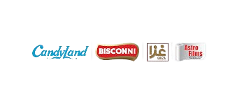**Ismail Industries Limited** is a leading Pakistani Confectionery, Snacks, Biscuits, Chocolates, and Packaging Materials manufacturer. Established in **1988**, it operates under well-known brands like **Candy** **Land**, **Bisconni**, and **Snack** **City**. The company is recognized for its quality products, innovation, and exports to international markets, with a strong focus on sustainability and customer satisfaction.

Figure 1: Muhammad M. Ismail Maqsood

# **MISSION**

**Ismail Industries** focuses on delivering high-quality, innovative, and accessible food products that promote a healthier lifestyle, ensuring sustainability, continuous improvement, and value to stakeholders.

# **VISION**

**Ismail Industries** aims to become a top food and consumer products company, known for quality, customer satisfaction, and social and environmental responsibility, expanding globally and domestically

# **CORE VALUES**

**Quality:** Commitment to maintaining the highest quality standards in products and processes.

**Innovation:** Fostering creativity and innovation to meet evolving consumer needs.

**Integrity:** Ensuring transparency, honesty, and ethical practices in all operations.

**Customer Satisfaction:** Prioritizing customer needs and exceeding their expectations.

**Sustainability:** Focused on eco-friendly practices and reducing environmental impact.

**Employee Empowerment**: Supporting and developing employees, encouraging teamwork and professional growth.

**Community Engagement:** Actively contributing to societal well-being and engaging in community development initiatives.

These guiding principles are intended to drive **Ismail Industries'** growth and impact in the food industry while creating value for consumers and stakeholders.

**OBJECTIVES OF ISMAIL INDUSTRIES LIMITED**

* **Deliver Quality Products:** To provide high-quality confectionery, snacks, biscuits, and packaging solutions that meet customer expectations.
* **Customer Satisfaction:** Enhance customer loyalty through innovation and consistency.
* **Sustainability:** Integrate eco-friendly and socially responsible practices in production and operations.
* **Market Leadership:** Expand the company's footprint domestically and internationally, becoming a top brand in the confectionery and snack sector.
* **Profitability:** Maintain strong financial growth while optimizing costs.

**SHORT-TERM GOALS**

1. **Product Launches:**

Introduce 2 new flavors of biscuits or snacks in the next 6 months.

1. **Customer Engagement:**

Increase customer loyalty by launching a rewards program by the end of the year.

1. **Operational Efficiency:**

Reduce production waste by 10% within the next 12 months.

1. **Digital Presence:**

Strengthen e-commerce platforms to boost online sales by 20% within the next year.

1. **Employee Training:**

Conduct training programs to enhance skills in quality control and sustainability practices by the next quarter.

**STATED GOALS**

**Publicly Communicated Objectives:**

1. Provide world-class products with sustainable practices.
2. Innovate and deliver quality confectionery and snacks.
3. Commit to being a responsible corporate citizen.
4. Reduce environmental impact and create positive social footprint.

**REAL GOALS**

1. Optimize production costs and supply chain efficiency for profit margins.
2. Strengthen brand recognition for retail market dominance.
3. Build distributor and retailer partnerships for market penetration.
4. Maximize returns on investment in new product development and marketing strategies.

**ORGANIZATIONAL APPROACH FOR GOAL SETTING**

**Ismail Industries** likely follows a structured and dynamic approach to goal setting, incorporating the following steps:

1. **Stakeholder Engagement:**

Goals are set through collaboration with key stakeholders such as management, employees, and investors.

1. **SMART Goal Framework:**

Goals are Specific, Measurable, Achievable, Relevant, and Time-Bound.

**Example:** Reduce energy usage in manufacturing facilities by 15% within 3 years.

1. **Performance Monitoring:**

Key Performance Indicators (KPIs) are defined to track progress, such as market share growth, production efficiency, and sales targets.

1. **Flexibility for Adaptation:**

Goals are regularly reviewed and updated based on market dynamics, consumer preferences, and economic conditions.

# **SWOT Analysis**

**1. Strengths:**

* **Innovative products:**

Ismail Industries has a strong research and development team that creates unique and innovative products, attracting customers and staying ahead of Competitors.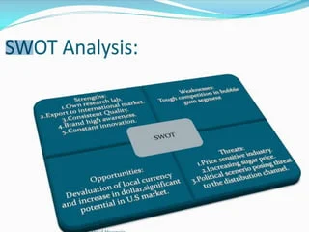

* **Strong partnerships:**

Strategic partnerships with multinational companies enhance Ismail Industries' reputation, provide access to new markets, and improve supply chain efficiency.

* **Efficient logistics:**

A well-established distribution network ensures timely delivery of products to retailers and customers.

Figure 2:SWOT ANALYSIS

* **Employee development programs:**

Investing in employee training and development enhances productivity, job satisfaction, and employee retention.

* **International quality standards:**

Compliance with ISO 9001:2015 ensures high-quality products, meeting global standards.

**2. Weaknesses:**

* **Seasonal demand fluctuations:**

Sales are affected by seasonal changes impacting on production planning and inventory management.

* **Limited global presence:**

Ismail Industries primarily operates in Pakistan, limiting its global market share.

* **High energy costs:**

Dependence on fossil fuels increases energy costs, impacting profitability.

* **Supply chain vulnerabilities:**

Disruptions in raw material supply can impact production.

* **Limited digital marketing:**

Ismail Industries may not effectively utilize digital platforms to reach customers.

**3.** **Opportunities:**

* **Halal and organic market expansion:**

Growing demand for halal and organic products offers new revenue streams.

* **E-commerce partnerships:**

Collaborating with e-commerce platforms increases online sales.

* **New market entry:**

Expanding into Central Asia, Africa, or other regions.

* **Sustainable packaging:**

Developing eco-friendly packaging enhances brand reputation.

* **Research and development investments:**

Continuously innovating products and processes.

**4. Threats:**

* **Increasing competition:**

Local and international competitors may challenge Ismail Industries' market share.

* **Global commodity price fluctuations:**

Changes in raw material prices impact on production costs.

* **Regulatory changes:**

Alterations in food safety regulations or taxes affect operations.

* **Economic instability:**

Pakistan's economic fluctuations impact consumer spending.

* **Cybersecurity risks:**

Digital operations vulnerability to cyber threats.

# **3.** **PESTEL Analysis**

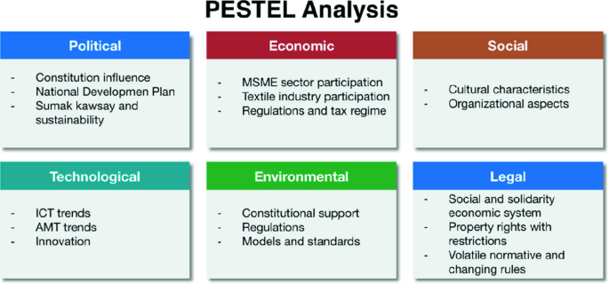**1. Political:**

* **Food safety regulations:**

Compliance with regulations ensures product quality.

* **Trade agreements:**

Pakistan's trade agreements impact import/export costs.

* **CPEC logistics impact**:

Figure 3: PESTAL analysis

China-Pakistan Economic Corridor enhances logistics efficiency.

**2. Economic:**

* **Pakistan's economic growth:**

GDP growth rate affects consumer spending**.**

* **Currency fluctuations:**

The PKR exchange rate impacts import costs.

* **Consumer spending trends:**

Changes in consumer behavior influence sales**.**

**3. Social:**

* **Growing demand for halal and organic food:**

Changing consumer preferences drives demand.

* **Changing consumer preferences:**

Health-conscious consumers seek new products.

* **Middle-class growth:**

Increasing middle-class population drives consumer spending**.**

**4. Technological:**

* **Automation and digital transformation:**

Improving efficiency through automation.

* **E-commerce integration:**

Enhancing online sales.

* **Data analytics:**

Informing business decisions with data.

**5. Environmental:**

* **Sustainable packaging:**

Reducing waste.

* **Climate change impacts:**

Mitigating climate change effects.

* **Water conservation:**

Efficient water usage.

**6. Legal:**

* **Food safety compliance:**

Adhering to regulations.

# **4.** **STRATEGIES WITH ISMAIL INDUSTRIES**

* **Corporate Strategy:**
* **Diversification:**

Operates multiple brands (Candyland, Bocconi) to spread risk and capture broader markets.

* **Market Expansion:**

Exports products globally for growth beyond Pakistan.

* **Vertical Integration:**

Uses Astro Films for packaging needs, reducing reliance on suppliers.

* **Stability Strategy:**
* **Core Focus:**

Maintains quality and market share for mature products like Bocconi.

* **Operational Efficiency:**

Limits expansion during economic uncertainty, improving internal processes.

* **Regional Stability:**

Focuses on consistent supply and customer satisfaction in local markets**.**

* **Implementation:**

Balances growth through diversification while stabilizing mature markets to ensure sustainability.

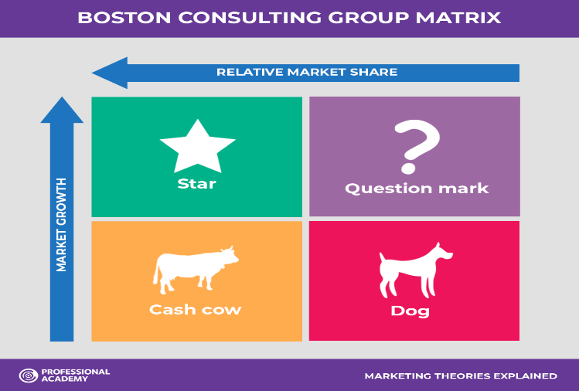**BCG MATRIX**

The **BCG Matrix** is a strategic business tool that was setup by **Boston Consulting Group (BCG).** The model classifies every product or business unit into one of four categories: Stars, Dogs, Cash Cows, or Question Marks.

Here’s how **Ismail Industries Ltd.** could apply the **BCG Matrix** to assess its different products or business units:

Figure 4: BCG MATRIX

**1. Stars**

High growth, high market share.

Products like **Bisconni biscuits** or **Candyland Candies** may be included in the category of **Stars** if those products dominate their segment whilst also showing potential for high growth internationally as well as locally. These products would require a lot of funds to assert leadership and invest in further growth.

**Strategy:** Keep engaging in market expansion, product promotion, and distribution in order to keep the leadership and use the high demand.

**2. Cash Cows**

High Market Share, Low Growth Market.

**High Market Share:** **Bisconni** is a well-known brand in **Pakistan**. It has a sizeable number of customers making it the biscuit market leader.

**Low Growth Market:** Increasing consumption of **Bisconni** products suggests that the biscuit market industry in **Pakistan** is at a time when rapid expansion is not likely to occur, but the demand remains steady over time.

**3. Question Marks**

High growth, low market share.

Newly incorporated or appearing products under **Ismail Industries’** range, such as the newly introduced snack or confectionery product which belongs to a fast-expanding category but is still not well established in the market, would be classified under Question Marks. These products have scope, but investments are necessary to push them into growth.

**Strategy:** Assess the market's likelihood of acceptance of the product. If it is deemed acceptable, consider investing more to hasten its penetration. Do not invest more in the product if a substantial investment may not be warranted.

**4. Dogs**

Low growth, low market share.

Any **Ismail Industries** product that has not been able to attract consumers and is currently in a stagnant or downward market would fall under this category. This could be an older product category that has been eclipsed by its competitors or one that has not been able to resonate with target consumers.

**Strategy:** Either phase these products out or look for ways to innovate them.

**PORTER'S FIVE FORCES MODEL**

**1. Threat of New Entrants in Food Industry**

• Moderate entry barriers due to established brands like Bisconni and Treat.

• Brand loyalty from established customers makes direct competition difficult.

• Significant capital investment required for effective competition.

**2. Ismail Industries Supplier Bargaining Power**

• Sources raw materials from diverse suppliers.

• Potential for increased bargaining power if relying on key suppliers.

• Cost of switching reduces supplier power if prices or quality increase.

**3. Bargaining Power of Customers in Snack and Confectionery Market**

• Moderate bargaining power due to competitive market and numerous choices.

• Brand loyalty reduces bargaining power.

• Price sensitivity and preferences influence demand.

**4. Threat of Substitutes in Confectionery and Snack Market**

• High availability of alternatives including local and international brands.

• Competition from chips, chocolates, biscuits.

• Changes in consumer preferences towards healthier options increasing threat.

**5. Pakistan's Snack and Confectionery Industry Rivalry**

• Highly competitive landscape with local and international brands.

• Pressure from Engro Foods, Mondelez, and others.

• Competitive pricing pressures on profit margins.

• Need for continuous innovation, product differentiation, and strong marketing for competitiveness.

# **ORGANIZATIONAL STRUCTURE**

Ismail Industries Limited's organizational structure outlines how tasks, supervision, and coordination are carried out to accomplish the objectives of the company. By establishing roles, duties, reporting lines, and communication styles, it establishes the framework in which the business functions.

**ELEMENTS OF ORGANIZATIONAL STRUCTURE**

* **Work Specialization:**

Employees focus on specialized roles like production, marketing, and finance for efficiency**.**

* **Departmentalization:**

It is divided into functional areas like Production, Marketing, Finance, and HR**.**

* **Chain of Command:**

A clear reporting hierarchy ensures accountability.

* **Span of Control:**

Managers oversee varying team sizes based on their roles.

* **Centralization:**

Decisions may be centralized at the top or delegated to departments.

* **Formalization:**

Standardized processes ensure consistency in operations.

**CEO / Managing Director**

│

┌─────────────┬─────────────┬────────────┐

│ │

Operations Marketing Finance Human Resources

│ │ │

Production & Advertising Accounting Recruitment

Development

│

Quality Control Sales Budgeting & Analysis Employee

Relations

**Organizational Design at Ismail Group**

**Ismail Group** follows a divisional structure to manage its diverse business areas (such as **manufacturing**, **trading**, and **distribution**). Each division operates with a focus on its industry, aligning with the group’s overarching strategic goals.

* **Hierarchy:** **Ismail Group** maintains clear layers of management, from top executives to department heads, enabling effective oversight and specialized expertise within each division.
* **Centralization and Decentralization:** Key strategic decisions are made by top management, but each division has autonomy over day-to-day decisions. This balance provides both control at the executive level and flexibility at the division level.
* **Benefits:** This structure allows **Ismail** **Group** to address specific needs in each business area, respond quickly to market changes, and manage risks effectively across divisions.

**Managerial Roles in Ismail Group**

**(Based on Mintzberg’s Framework)**

**Ismail Group’s** managers play various roles essential for smooth operations and competitive advantage:

* **Interpersonal Roles:** Managers act as leaders by guiding teams, representing Ismail Group at events, and building strong relationships with stakeholders and clients.
* **Informational Roles:** They gather market and industry information, keeping team members updated on company goals and performance trends.
* **Decisional Roles:** Managers make critical decisions related to innovation, resolve operational issues, allocate resources, and negotiate favorable deals with suppliers and partners.

This blend of roles enables **Ismail Group’s** managers to manage diverse divisions effectively and sustain a strong position in the market.

**How organizations empower their employees**

1. **Encouraging Autonomy and Decision-Making**

* Allows employees to make decisions in their roles.
* Promotes ownership of projects and responsibilities.

1. **Provides training and skill development opportunities.**

* Supports career advancement through mentorship.
* Provides training and skill development opportunities.

1. **Open Communication and Feedback**

* Encourages transparent conversations between leaders and staff.
* Actively seeks and values employee input for improvement.

1. **Recognizing Contributions and Offering Rewards**

* Acknowledges employee achievements and milestones.
* Offers rewards and incentives for high performance.

**LEADERSHIP STYLE**

1. **Transformational Leadership for Innovation and Motivation**

* Inspires employees through a shared vision.
* Promotes personal growth and creativity.

1. **Transactional Leadership for Clear Goals and Accountability**

* Sets clear expectations and rewards performance.
* Corrects issues to maintain productivity.

1. **Democratic Leadership for Employee Involvement and Collaboration**

* Involves employees in decision-making.
* Encourages teamwork and open communication.

1. **Situational Leadership for Flexibility and Adaptability**

* Adjusts leadership style based on team needs.
* Provides appropriate guidance based on the situation.

**RECOMMENDATIONS**

**1. Product Innovation:**

* To keep up with global trends, increase the selection of healthy snacks and employ environmentally friendly packaging**.**

**2. Market Growth:**

* Expand e-commerce's reach and focus on unexplored markets like Southeast Asia.

**3. Sustainability:**

* To draw in investors, use renewable energy sources and increase ESG transparency.

**4. Marketing:**

* To improve brand engagement, use loyalty programs and digital advertising**.**

**5. Efficiency:**

* To cut expenses, automate production and streamline the supply chain**.**

**6. Financial Focus:**

* Look into cost-sharing arrangements and effectively manage debt.